### **A CRM APPLICATION FOR WHOLESALE RICE MILL**

**By**

**Arpit Dhoundiyal**

[**arpitdhoundiyal@gmail.com**](mailto:arpitdhoundiyal@gmail.com)

**Project Abstract**

**Project Abstract: Rice Mill CRM Application**

The Rice Mill CRM Application is a tailored solution designed to meet the unique operational needs of a wholesale rice mill. By leveraging Salesforce's powerful customer relationship management (CRM) capabilities, this application aims to enhance the efficiency of daily operations, improve customer experiences, and streamline decision-making processes for rice mill owners. The project focuses on delivering a user-friendly interface with robust features, enabling rice mill owners to effectively manage their business.

### **Key Features:**

1. **Reporting and Dashboards**:
   * Generate detailed daily reports on rice production, sales, and revenue.
   * Visualize data through dashboards to track popular rice types and top customers, aiding in strategic planning and resource allocation.
2. **Rollup Summary Fields**:
   * Summarize data from child objects (e.g., rice details) to parent objects (e.g., suppliers) using functions like COUNT, SUM, MIN, and MAX.
   * Example: Calculate the total amount of rice supplied by each supplier.
3. **Cross-Object Formula Fields**:
   * Create formulas that reference fields from related objects to perform complex calculations.
   * Example: Calculate the total payment amount by multiplying the quantity of rice purchased by the price per kilogram.
4. **Validation Rules**:
   * Implement validation rules to ensure data integrity, displaying error messages when invalid values are entered.
   * Example: Use the ISBLANK formula to prevent empty fields from being submitted.
5. **Permission Sets and Security**:
   * Configure Organization-Wide Defaults (OWD) and roles to control access to records.
   * Ensure that owners can view all records, while employers and workers have restricted access based on their roles.

### **Prerequisites:**

* A Salesforce Developer account.
* Knowledge of Salesforce admin concepts.
* Two web browsers installed on the machine.
* Good internet connectivity.

### **Learning Outcomes:**

* Hands-on experience with a real-time Salesforce project.
* Understanding of object relationships, formula fields, validation rules, and cross-object formulas in Salesforce.
* Proficiency in creating page layouts, rollup summary fields, reports, and dashboards.

This project equips developers and admins with the skills to design and implement a customized CRM application for a wholesale rice mill, ensuring efficient management of daily operations and data-driven decision-making.

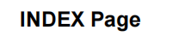

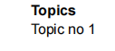

* Introduction To Salesforce
* Object
* Tabs
* The Lightning App
* Fields
* Page Layouts
* Profiles
* Role & Role Hierarchy
* Users
* Permission Sets
* Report
* Dashboards
* APEX

# **INTRODUCTION**

**The Rice Mill CRM Application is designed to streamline operations in a wholesale rice mill by leveraging Salesforce's CRM capabilities. This user-friendly application helps owners manage daily rice production, sales, and revenue through features like detailed reporting and dashboards. It also includes rollup summary fields for aggregating data, cross-object formula fields for complex calculations, and validation rules to ensure data integrity. Additionally, the application provides robust security through permission sets and roles, ensuring appropriate access levels for owners, employers, and workers. This project serves as a comprehensive tool for enhancing efficiency and making data-driven decisions in a rice mill environment.**

**TASK 1:**

* **Creating Developer Account**
* Creating a developer org in salesforce.
* Go to <https://developer.salesforce.com/signup>
* On the sign up form, enter the following details :
* 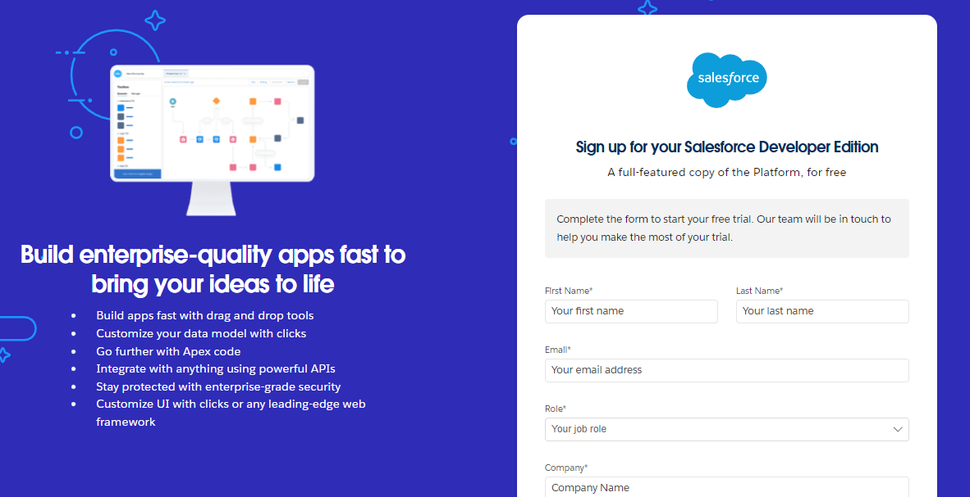
* First name & Last name
* Email
* Role : Developer
* Company : College Name
* County : India
* Postal Code : pin code
* Username : should be a combination of your name and company
* This need not be an actual email id, you can give anything in the format : [username@organization.com](mailto:username@organization.com)
* Click on sign me up after filling these.
* Account Activation
* Go to the inbox of the email that you used while signing up. Click on the verify account to activate your account. The email may take 5-10mins.
* 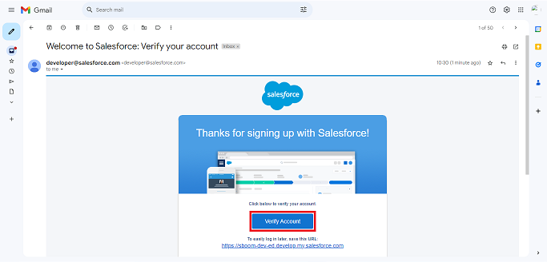
* Click on Verify Account
* Give a password and answer a security question and click on change password.
* 
* Then you will redirect to your salesforce setup page.

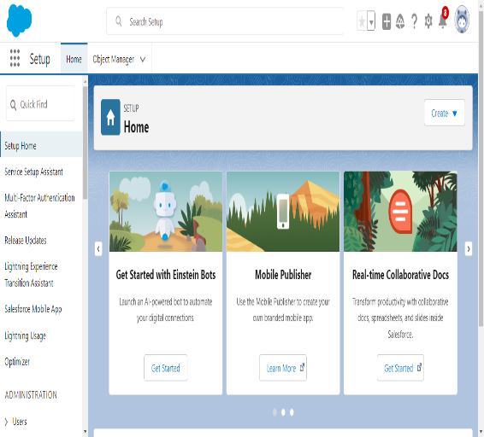

**TASK 2: OBJECT**

* **Create Supplier Object**
  + To create an object:
  + From the setup page >> Click on Object Manager>> Click on Create>>Click on Custom Object.
  + Enter the label name>>supplier
  + Plural label name>>supplier
  + Enter Record Name Label and Format
  + Record Name >> supplier Name
  + Data Type>>Text
  + Click on Allow reports and Track Field History and allow search
  + Allow search >> Save.
* **Create Rice Mill Object** 
  + To create an object:
  + From the setup page >> Click on Object Manager>>Click on Create >> Click on Custom Object.
  + Enter the label name>>rice mill
  + Plural label name>> rice mills
  + Enter Record Name Label and Format
  + Record Name >>
  + Data Type >> Auto Number
  + Display Format >> rice-{000}
  + Starting number >> 1
  + Click on Allow reports and Track Field History, Allow Search and Save.
* **Create Consumer Objects** 
  + Use these display format for the consumer
  + label name >> consumer
  + Plural label name >> consumers
  + Display Format >> consumers-{000}
  + Starting number >> 1

**Create Rice Details Objects**

* label name >> rice details
* Plural label name >> rice details
* Display Format >> rice-{000} Starting Number >>1

**TASK 3: Tabs**

* **Creating A Custom Tab**
  + To create a Tab:( supplier)
  + Go to setup page >> type Tabs in Quick Find bar >> click on tabs >> New (under custom object tab)
    - 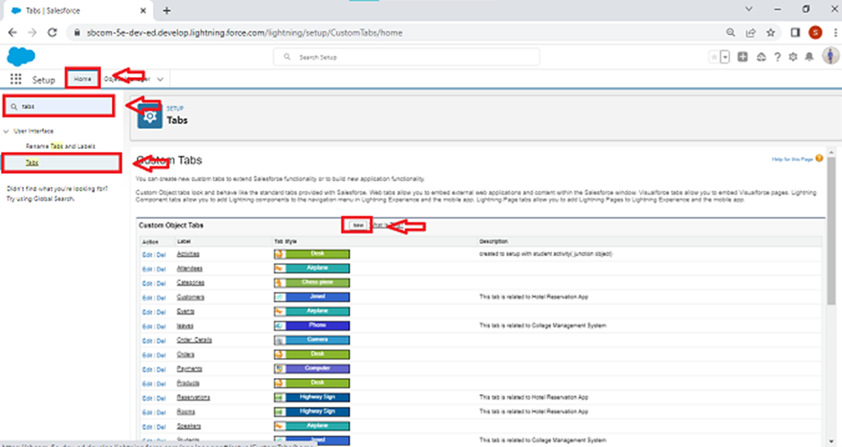
  + Select Object( supplier) >> Select the tab style >> Next (Add to profiles page) keep it as default >> Next (Add to Custom App) uncheck the include tab .
  + Make sure that the Append tab to users' existing personal customizations is checked.
  + Click save.
    - 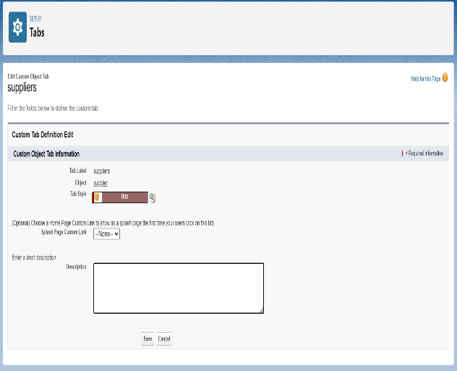
    - 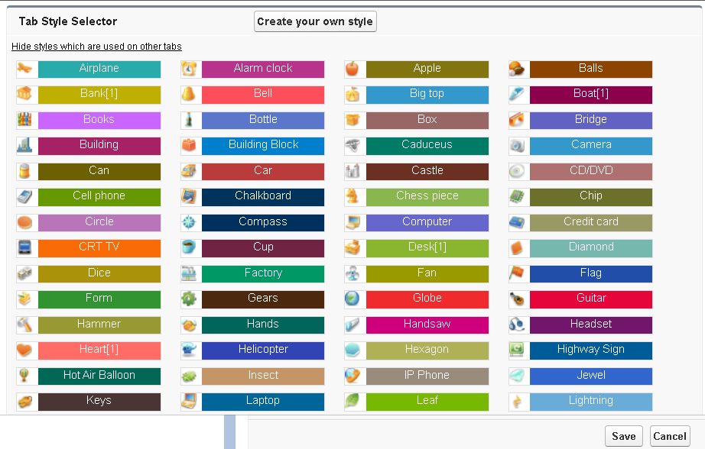

* + - 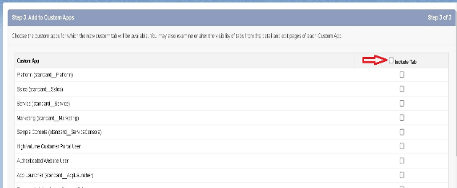
    - 

* + - 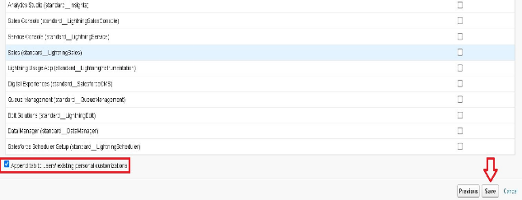
* **Creating Remaining Tabs**
  + Now create the Tabs for the remaining Objects, they are “ rice mill, consumer , rice details”.
  + Follow the same steps as mentioned in Activity -1 .

**TASK 4: The Lightning App**

* **Create A Lightning App**
* Go to setup page >> search “app manager” in quick find >> select “app manager” >> click on New lightning App.
* 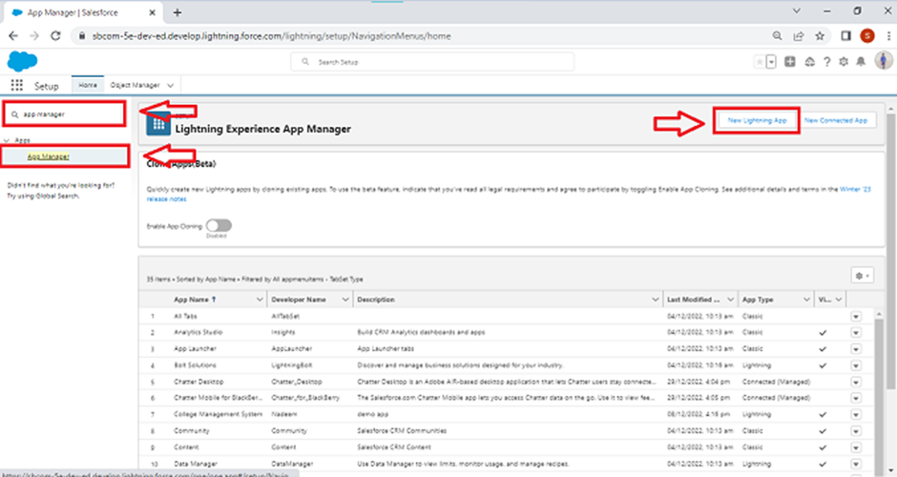
* Fill the app name in app details as MY RICE >> Next >> (App option page) keep it as default >> Next >> (Utility Items) keep it as default >> Next.
* 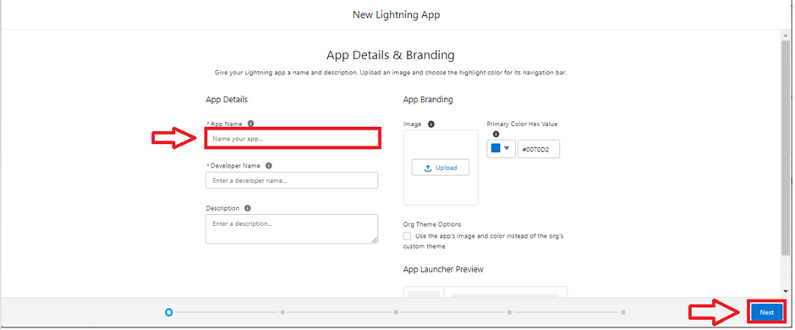
* Upload a photo that is related to your app.
* To add Navigation Item:
* 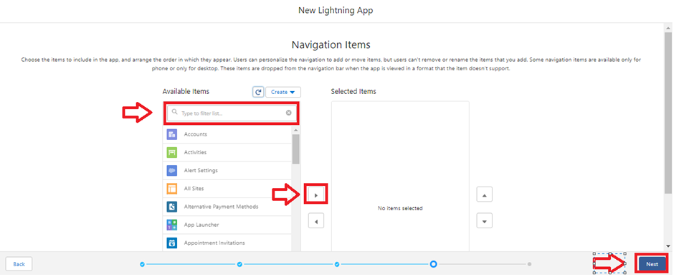
* Select the items (supplier, rice mill, consumer , Rice details ) from the search bar and move it using the arrow button >> Next.
* To Add User Profiles:
* 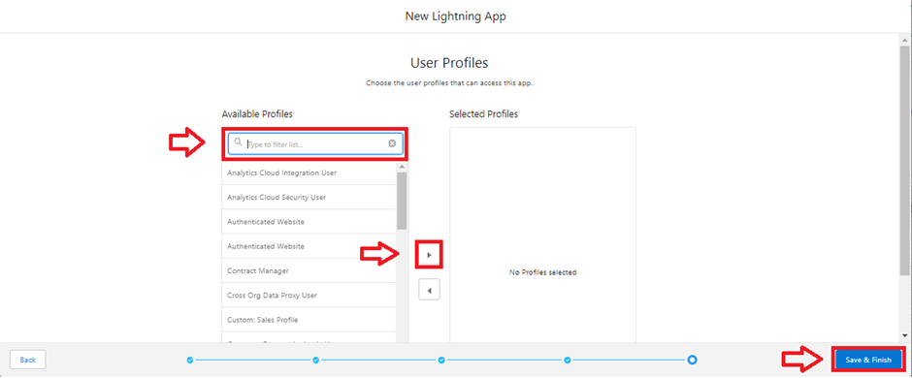
* Search profiles (System administrator) in the search bar >> click on the arrow button >> save & finish.

**TASK 5: Fields**

* **Creating The Number Field In Rice Details object**
* Go to the setup page >> click on object manager >> From drop down click edit for rice details object
* 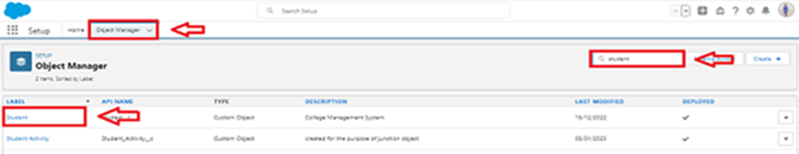
* Click on fields & relationship >> click on New.
* 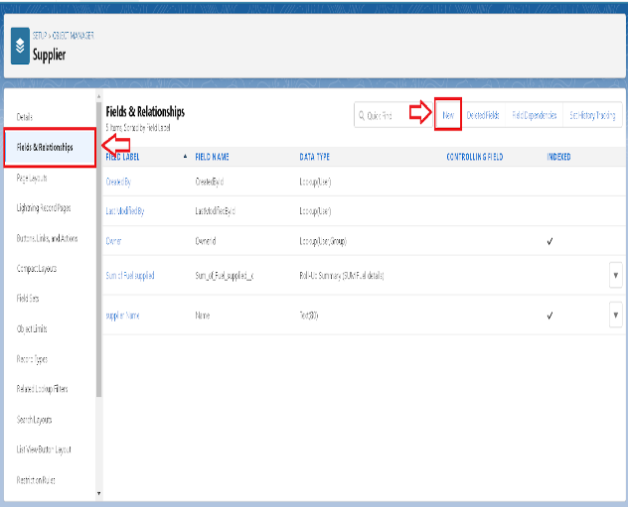
* Select Data type as “Number” and click Next.
* Given the Field Label as “ rice distributed ” and length as “ 5 ”.  
  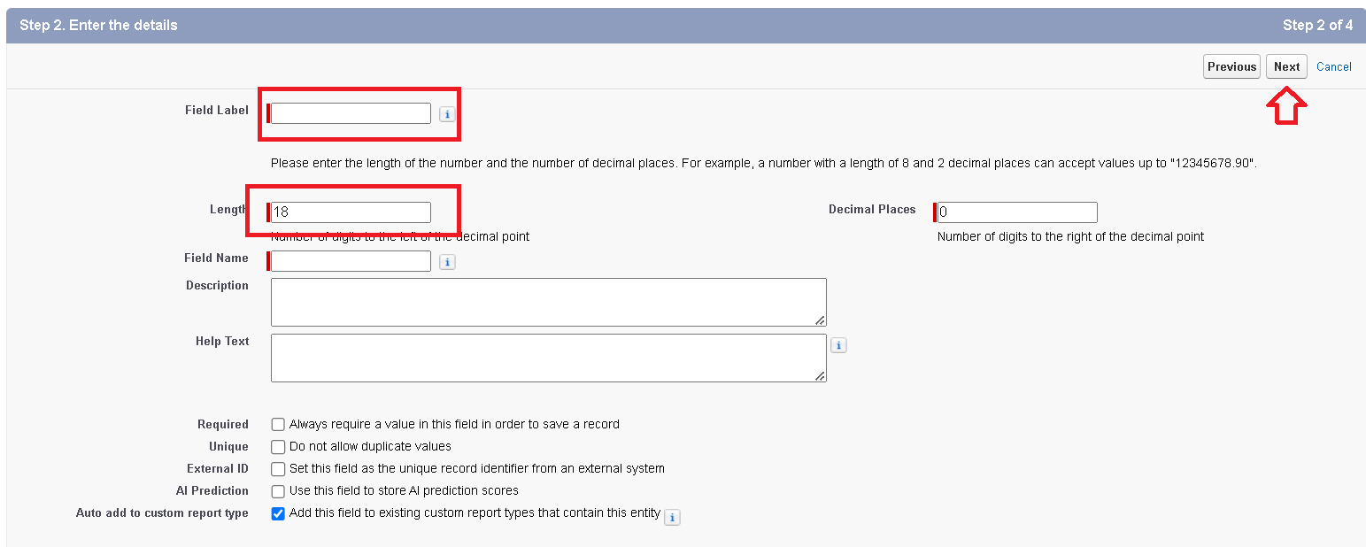
* Field Name will be auto populated, and click on Next- Next >> Save.
* **Creating junction object**
  + Go to the setup page >> click on object manager >> From drop down click edit for rice details object
  + 
* Click on fields & relationship - click on New.
  + 
* Select “Master-Detail relationship” as data type and click Next.

  + 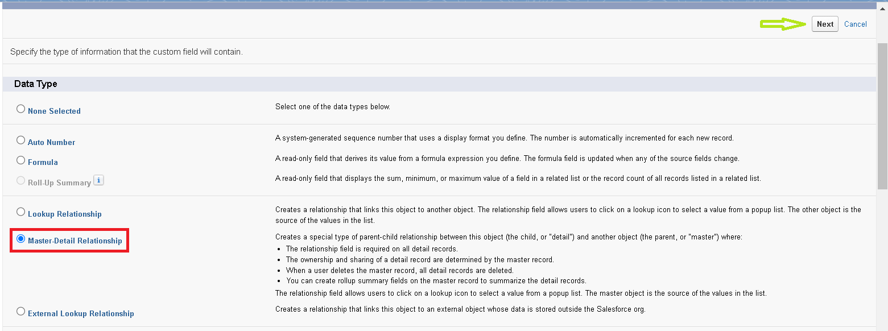
* Select the related object “ supplier ” and click next.

  + 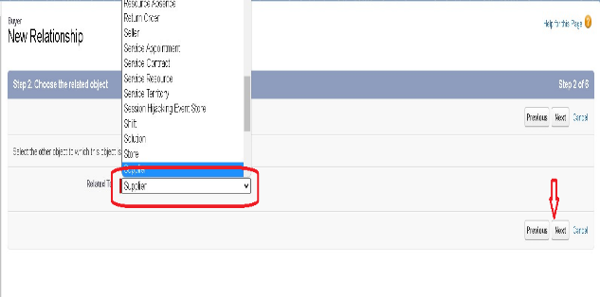
* Give Field Label as “supplier Name” and click Next.
* Next >> Next >> Save & New.
* Follow the same steps from 1 to 3.
* Select the related object “ rice mill ” and click Next.
* Give Field Label as “rice mill 1(one)” and click Next.
* Next >> Next >> Save.
* **Creating A master detail relationship**
* Go to the setup page >> click on object manager >> From drop down click edit for consumer object.
* Click on fields & relationship >> click on New.
* Select “Master-Detail relationship” as data type and click Next.
* Select the related object “ rice mill”.
* Give Field Label as “rice mill name” and click Next.
* Next >> Next >> Save.
* **Creating the roll-up summary**
* Go to setup >> click on Object Manager >> type object name(supplier) in search bar >> click on the object.
* 
* Now click on “Fields & Relationships” >> New
* 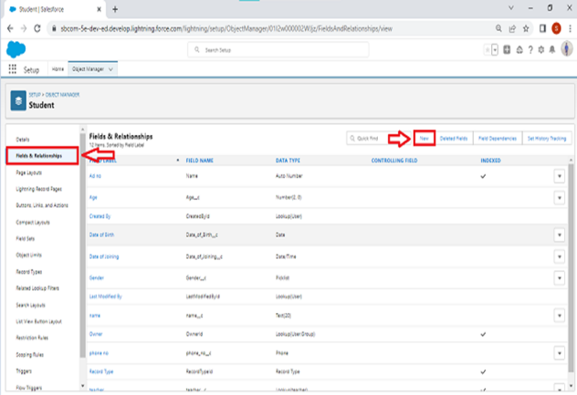
* Select the data type as “Rollup summary ”,and click Next.  
    
  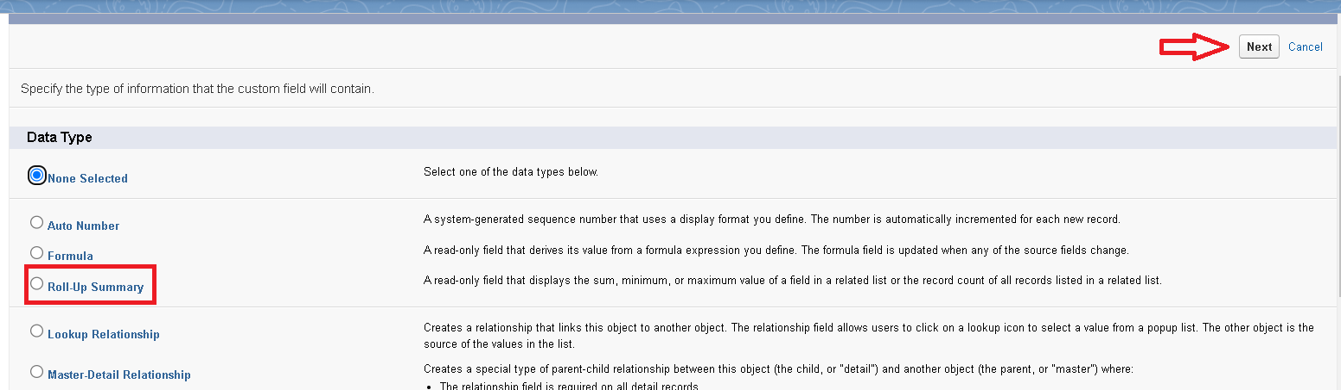
* Give the Field label as “ sum of rice distributed ”,Field Name will be Auto generated, and click Next.  
   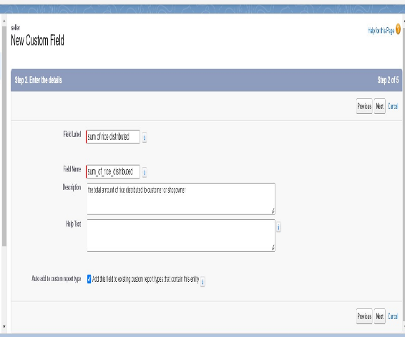
* Select the summarized object as “ rice details ”.
* Select the Rollup type as “sum”.
* Select the field to aggregate as “ rice distributed ”, and click Next >>Next >>Save.
* 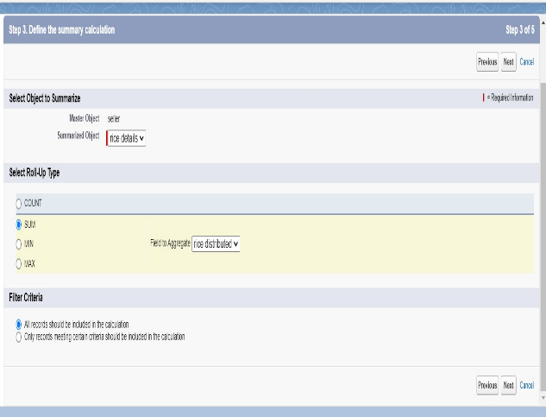
* Follow the same steps for the rice mill Object from 1 to 3
* Give the Field label as “ rice distributed to shops ”,Field Name will be Auto generated, and click Next.
* Select the summarized object as “ rice details ”.
* Select the Rollup type as “sum”.
* Select the field to aggregate as “ rice distributed ”, and click Next >> Next >> Save.
* Note : create the field as “ rice taken by shops in kgs” using number datatype in consumer object
* Follow the same steps for the rice mill Object from 1 to 3
* Give the Field label as “ rice taken ”,Field Name will be Auto generated, and click Next.
* Select the summarized object as “ consumer”.
* Select the Rollup type as “sum”.
* Select the field to aggregate as “ rice taken in shops ”, and click Next >> Next >> Save.
* **Creating fields in objects**
* Go to the setup page >> click on object manager >> From drop down click edit for rice details object.
* Click on fields & relationship >> click on New.
* 
* Select Data type as “master detail” and click Next.
* Given the Field Label as “ supplier name ” and length as “ 5
* 
* Field Name will be auto populated, and click on Next>> Next >>Save.
* **Creating Fields In Rice Mill Objects**
* Select Data type as “Number” and click Next.
* Given the Field Label as “ rice price/kg ” and length as “ 5 ”
* **Creating Cross Object formula field in consumer object**
* Go to setup >> click on Object Manager >> type object name(consumer) in search bar >> click on the object.
* Click on fields & relationship >> click on New.
* Select Data type as “Formula” and click Next.
* Give Field Label and Field Name as “Amount Paid ” and select formula return type as “Number” and click next.
* **Creating The validation rule**
* Go to the setup page >>click on object manager >> From drop down click edit for consumer object.
* Click on the validation rule >> click New.  
   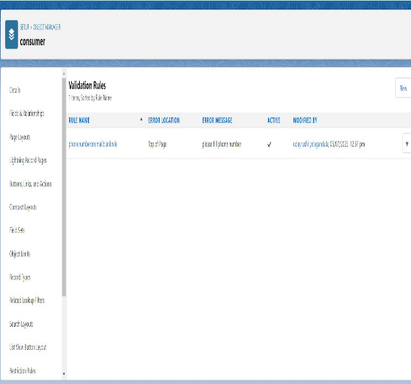
* Enter the Rule name as “Phonenumberoremailblankrule ”.
* Enter the description as “phone number and email number should not be blank”.
* Enter the formula as “OR( ISBLANK( phone_number__c ) , ISBLANK( email__c ) )” and check the syntax.
* 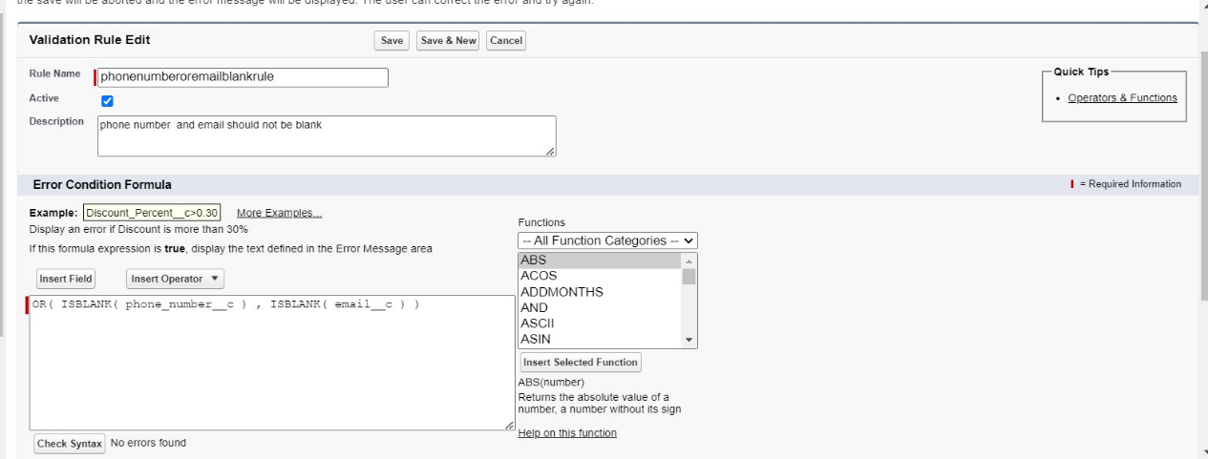
* Under the error message write as”please fill in your phone number.”
* Select error location “top of page”.
* 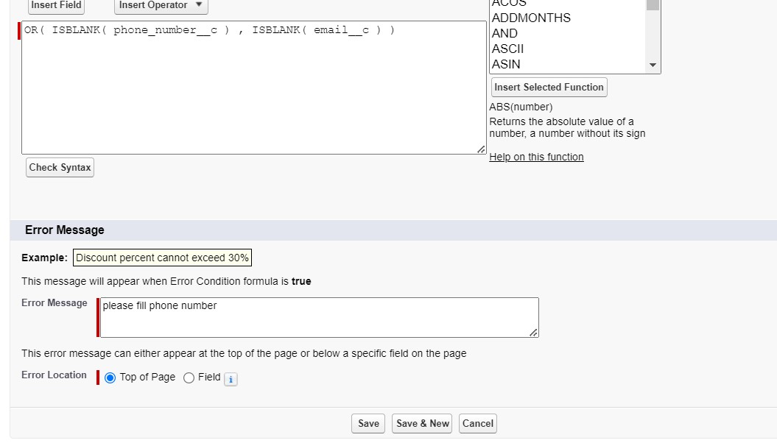
* Save the validation rule.

**TASK 6: Page Layouts**

* **Creating The page layout**
* Go to Setup >> Click on Object Manager >>Search for the object (consumer) >> From drop down select the object and click on it.
* Click on Page layout >> Click on New.
* 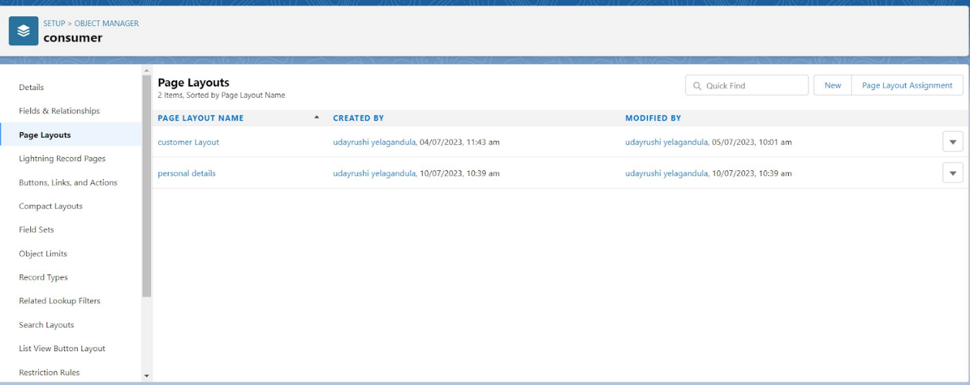
* Select the existing page layout, and give the page layout name as “consumer layout”, and click save. 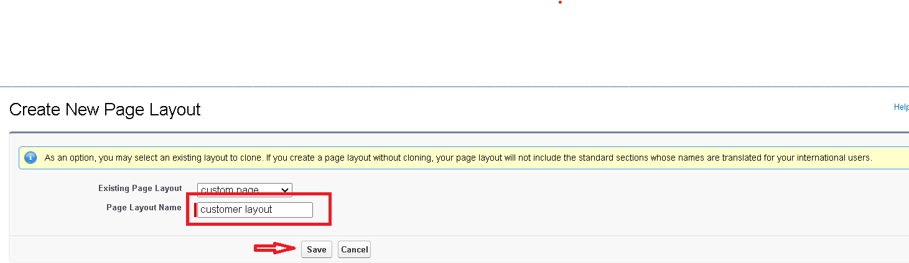
* Drag and drop the section field to consumer details and create the section.
* Enter the section name as “Personal details”, - click Ok.
* 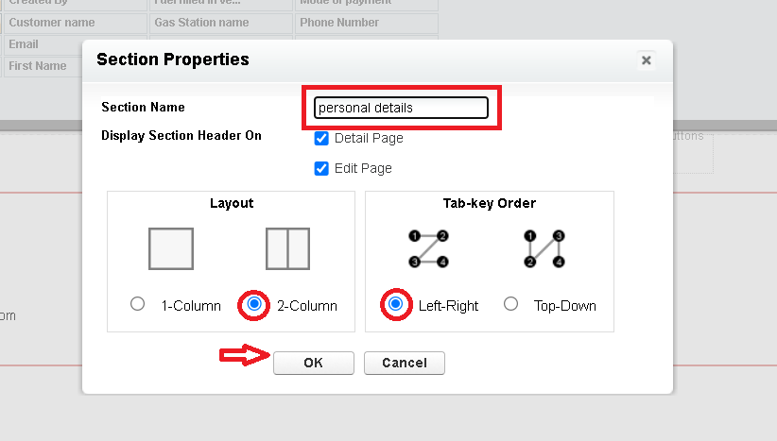
* Now drag the fields to this section that mentioned , they are
* First name , last name , consumer name , phone number, email, rice mill name.
* Follow the same process for another two sections as shown above , they are
* One section is “ rice details ” , drag the fields that are
* Rice taken by shop, rice type.
* Another section is “Receipt details ”, and drag the fields that are
* Mode of payment , Amount paid.
* Then , Click save.
* 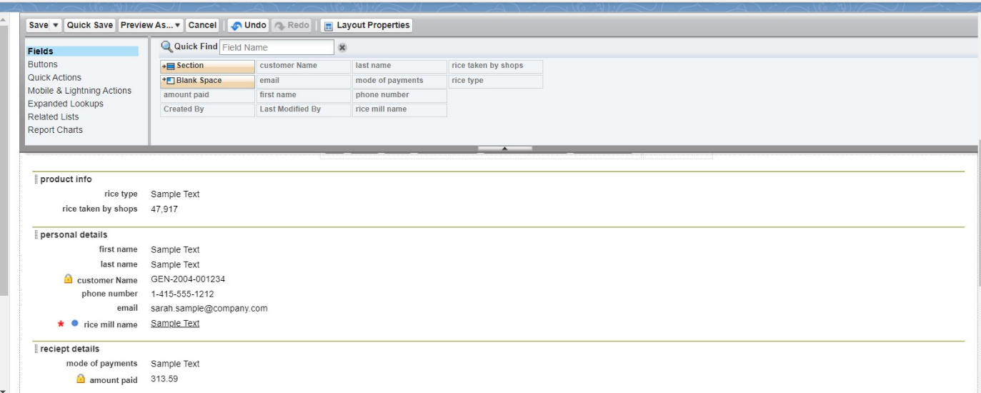

**TASK 7: Profiles**

* **Owner Profile**
* Go to setup >> type profiles in quick find box >> click on profiles >> clone the desired profile (Standard User) >>enter profile name (owner) >> Save.
* 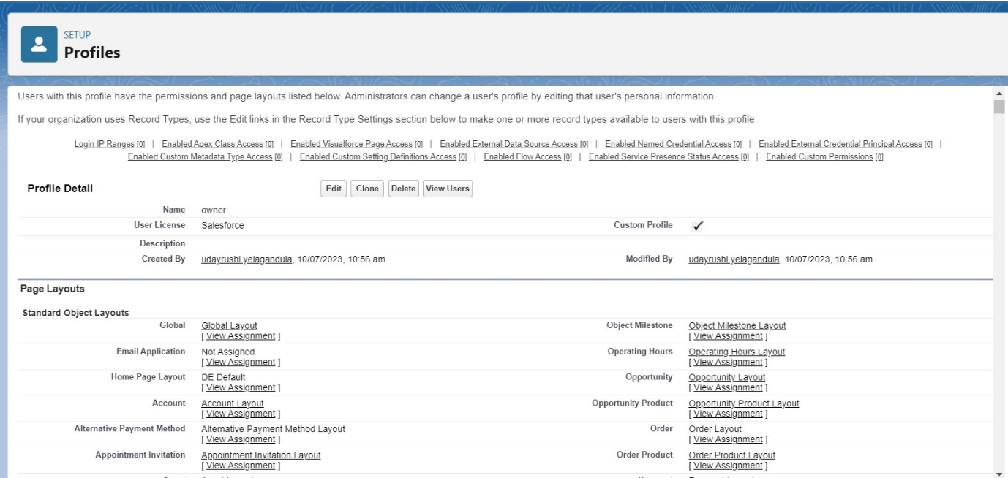
* Scroll down to Custom Object Permissions and Give access permissions for consumers, rice details , rice mill and suppliers objects as mentioned in the below diagram.
* 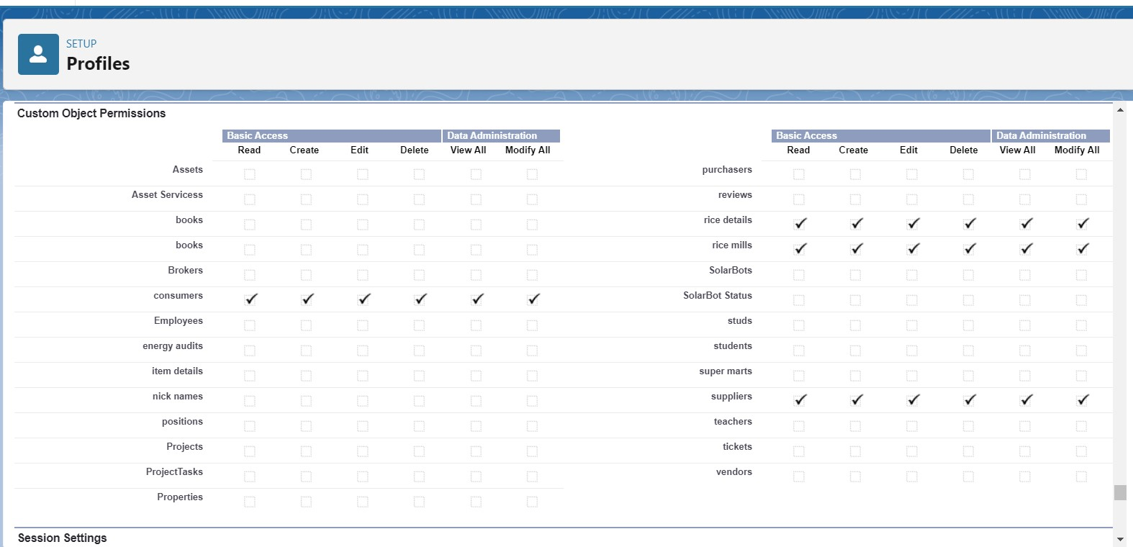
* Give access and save it.
* **Employer Profile**
* Go to setup >> type profiles in quick find box >>click on profiles >> clone the desired profile (Standard Platform User) >> enter profile name (employer) >> Save.
* While still on the profile page, then click Edit.
* Select the Custom App settings as default for the rice mill.
* Scroll down to Custom Object Permissions and Give access permissions for consumer, rice details , rice mill and suppliers objects as mentioned in the below diagram.
* 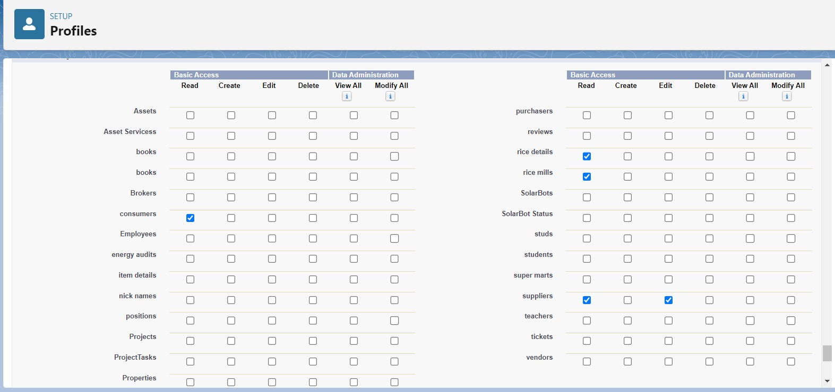
* And click save.
* **Worker Profile**
* Go to setup >> type profiles in quick find box >> click on profiles >> clone the desired profile (Standard Platform User) >> enter profile name (worker) >> Save.
* While still on the profile page, then click Edit.
* Select the Custom App settings as default for the rice mill.
* Scroll down to Custom Object Permissions and Give access permissions for consumer, rice details , rice mill and suppliers objects as mentioned in the below diagram.
* 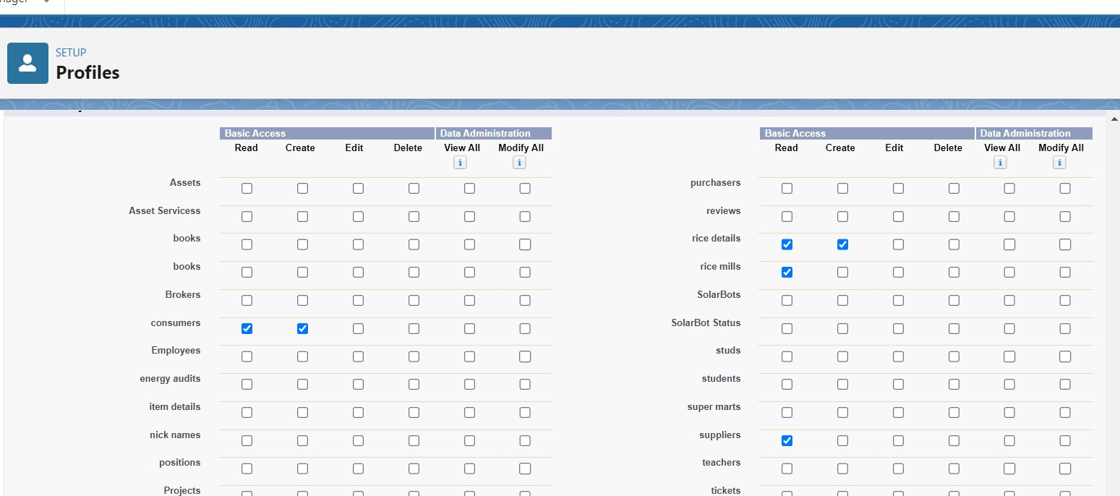
* And click save.

**TASK 8: Role & Role Hierarchy**

* **Creating Owner Role**
* Go to quick find >> Search for Roles >> click on set up roles.
* Go to quick find >> Search for Roles >> click on set up roles.  
   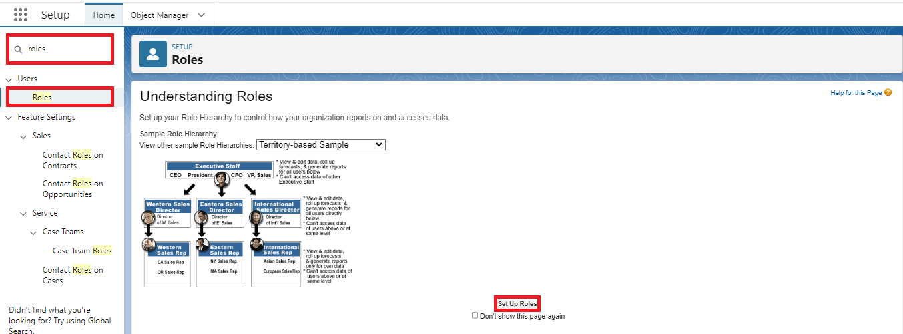
* Click on Expand All and click on add role under whom this role works.  
  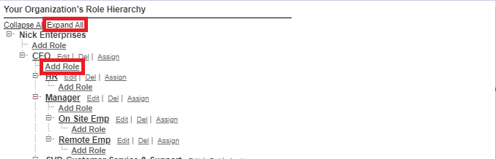
* Give Label as “owner” and Role name gets auto populated. Then click on Save  
    
  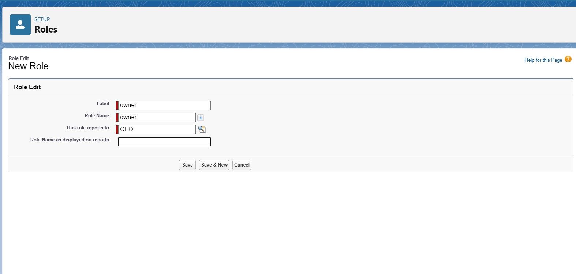
* Click and save it.

**Creating Employer Roles**

* Go to quick find >>Search for Roles >>click on set up roles.
* Click plus on CEO role, and click add role under owner.  
    
  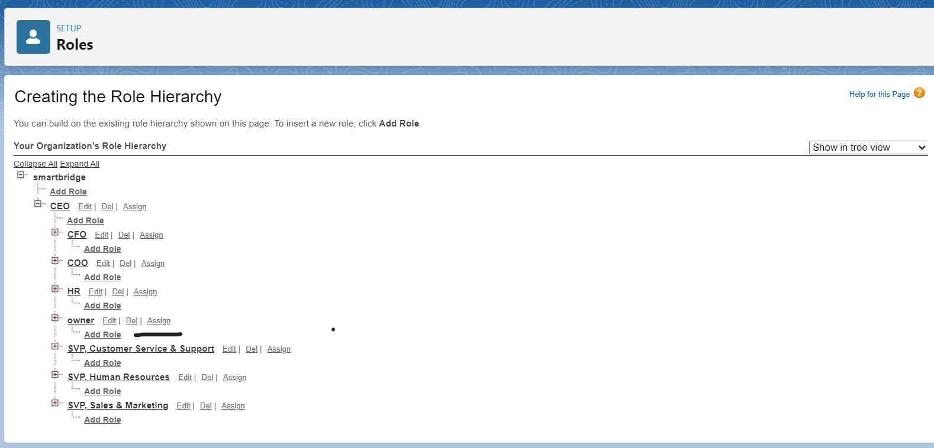
* Give Label as “employer” and Role name gets auto populated. Then click on Save.
* Repeat the same steps, for another role.
* Click plus on CEO role, and click plus on owner, and click add role under employer.  
    
  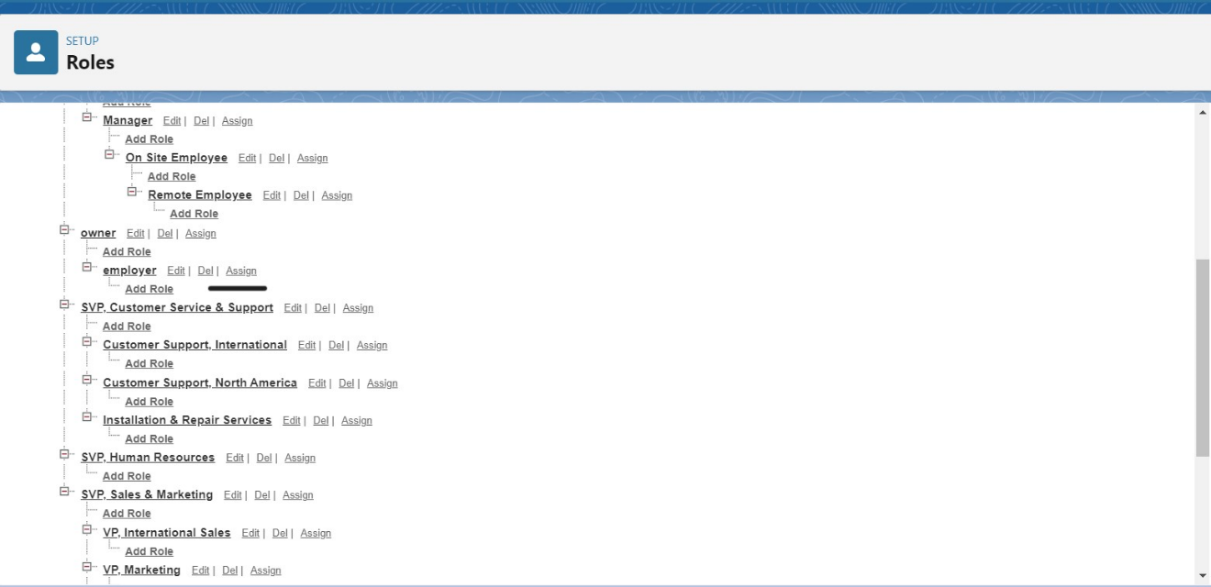
* give Label as “worker” and Role name gets auto populated. Then click on Save.

**TASK 9: Users**

* **Create User**
* Go to setup >> type users in quick find box >> select users >> click New user.
* Fill in the fields
* First Name : vicky
* Last Name : y
* Alias : Give a Alias Name
* Email id : Give your Personal Email id
* Username : Username should be in this form: [text@text.text](mailto:text@text.text)
* Nick Name : Give a Nickname
* Role : owner
* User license : Salesforce
* Profiles : owner.  
  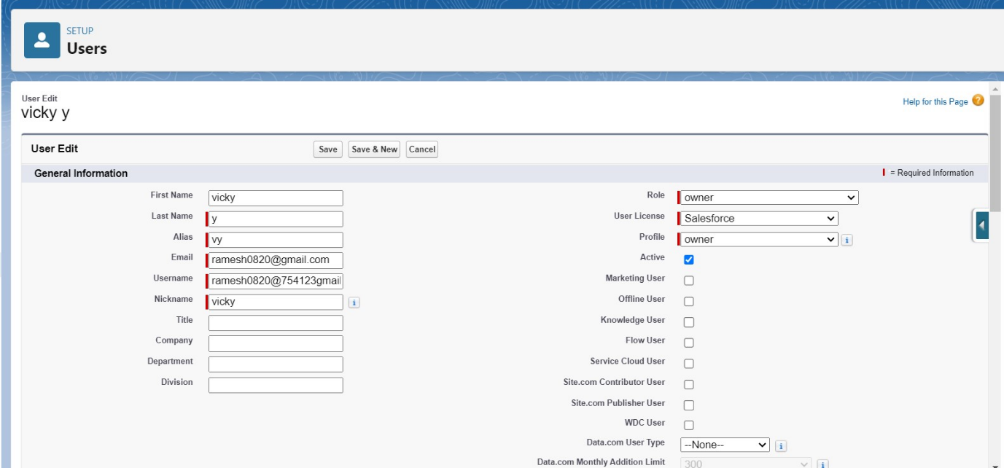
* Save it.
* **Creating Another Users**
* Go to setup ? type users in quick find box ? select users ? click New user.
* Fill in the fields
* First Name : ram
* Last Name : ram
* Alias : Give a Alias Name
* Email id : Give your Personal Email id
* Username : Username should be in this form: [text@text.text](mailto:text@text.text)
* Nick Name : Give a Nickname
* Role : employer
* User license : Salesforce platform
* Profiles : standard platform user.
* **Create Another User**
* Go to setup ? type users in quick find box ? select users ? click New user.
* Fill in the fields
* First Name : ragu
* Last Name : raj
* Alias : Give a Alias Name
* Email id : Give your Personal Email id
* Username : Username should be in this form: [text@text.text](mailto:text@text.text)
* Nick Name : Give a Nickname
* Role : worker
* User license : Salesforce platform
* Profiles : standard platform user.

**TASK 10: Permission Sets**

* **Creating OWD Setting**
* Go to setup >> type “sharing settings ” in quick search >> Click edit.  
    
  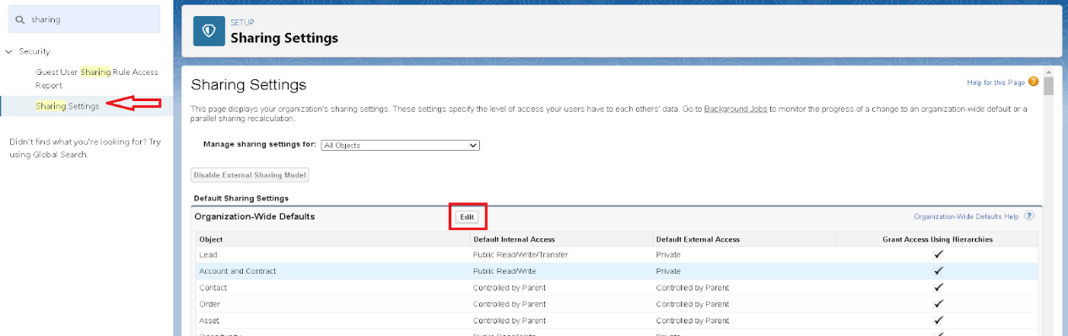
* Scroll down, change the default internal access to “ public read-only” for rice mill and supplier object.
* Click save.
* Extra information, By these every profile has their own access, according to their profile.
* But in our case we created roles and given the roles in such a way that the owner can see employer and worker records , and the employer can see the worker records.

**TASK 11: Report**

* **Create Report**
* Go to the app >>click on the reports tab
* Click New Report.  
  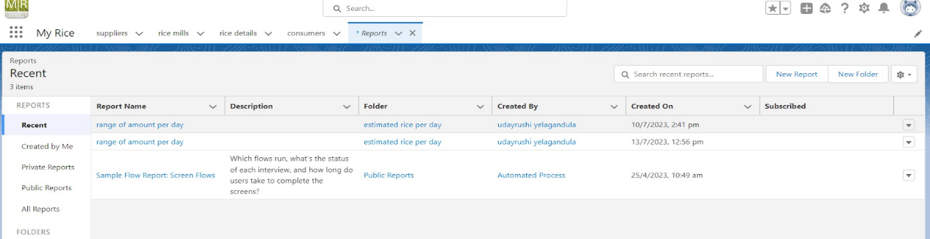
* select for report type, search for “rice mill with consumers” click on it. And click on start report.
* 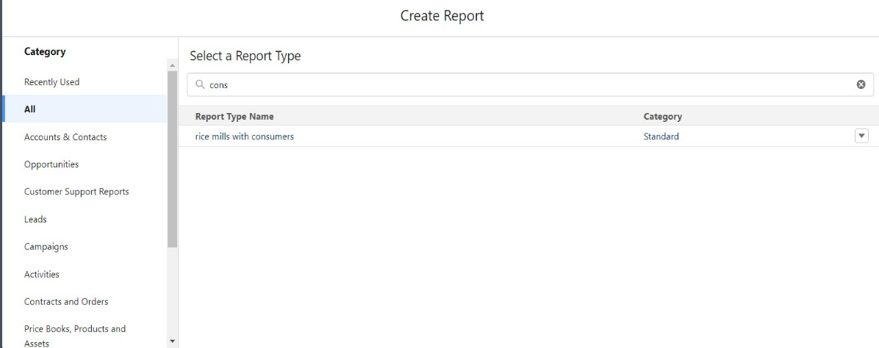
* Their outline pane is opened already, select the fields that are mentioned below in the column section.
* 1.consumer name
* 2.rice type
* 3.rice price/kg
* 4.mode of payments
* 5.amount paid
* Remove the unnecessary fields.
* Select the fields that are mentioned below in the GROUP ROWS section.
  + Rice taken by shops  
    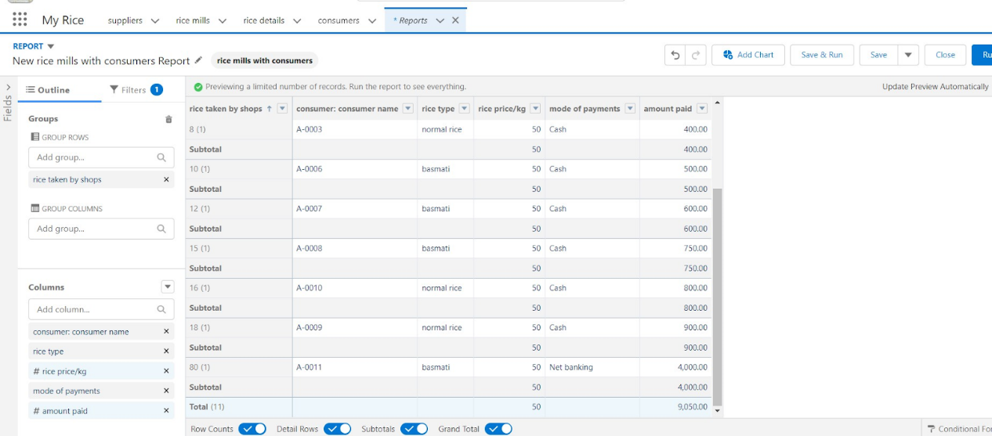
* Click save and run and save the report as “range of amount per day”.and save it.  
  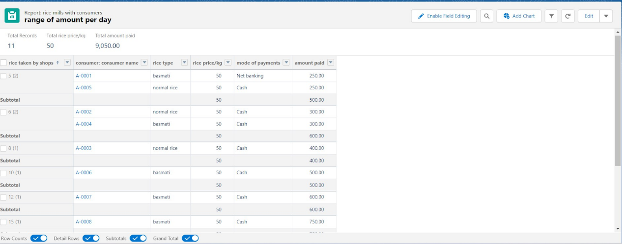
* **Sharing Report To Owner**
* Click edit drop down and select subscribe option   
    
  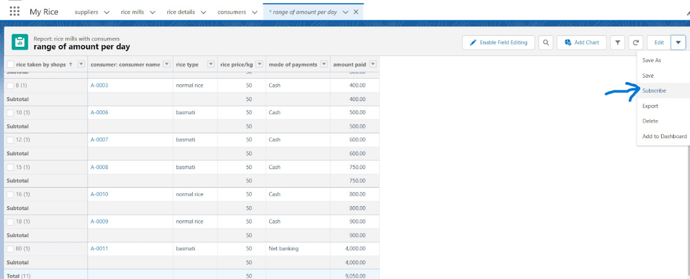
* Follow as per below image.
* 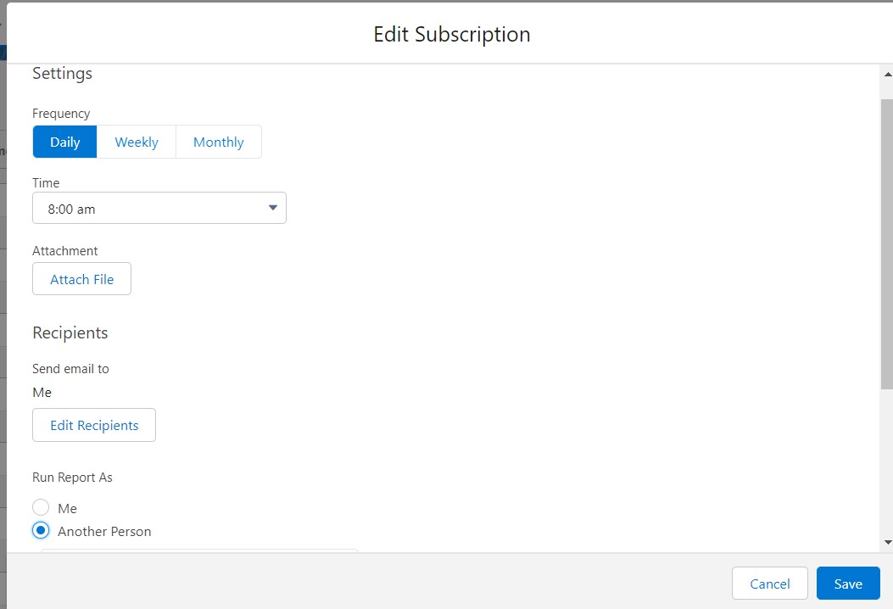
* After selecting the run report as a “another person” select your personal account or whom you want to send that mail to.
* Click save.
* **Create A Report Folder**
* Click on the app launcher and search for reports.
* Double click on the report, “ reports tab” will be auto populated in the navigation bar.
* Click on the report tab, click on the new folder.
* 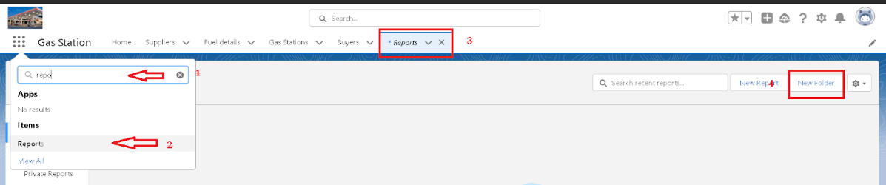
* Give the Folder label as “estimated rice per day ”, Folder unique name will be auto populated.
* Click save.
* 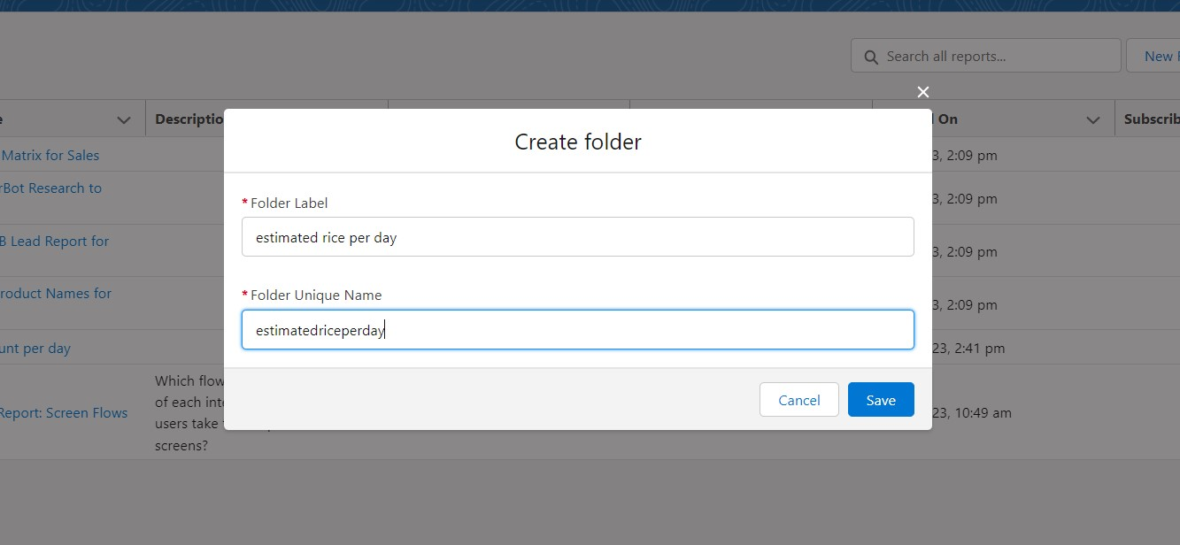
* 1.navigate to app launcher and click reports on that.
* 2.click all reports.
* 3. Select the range of amount per day drop down in that click move.  
    
  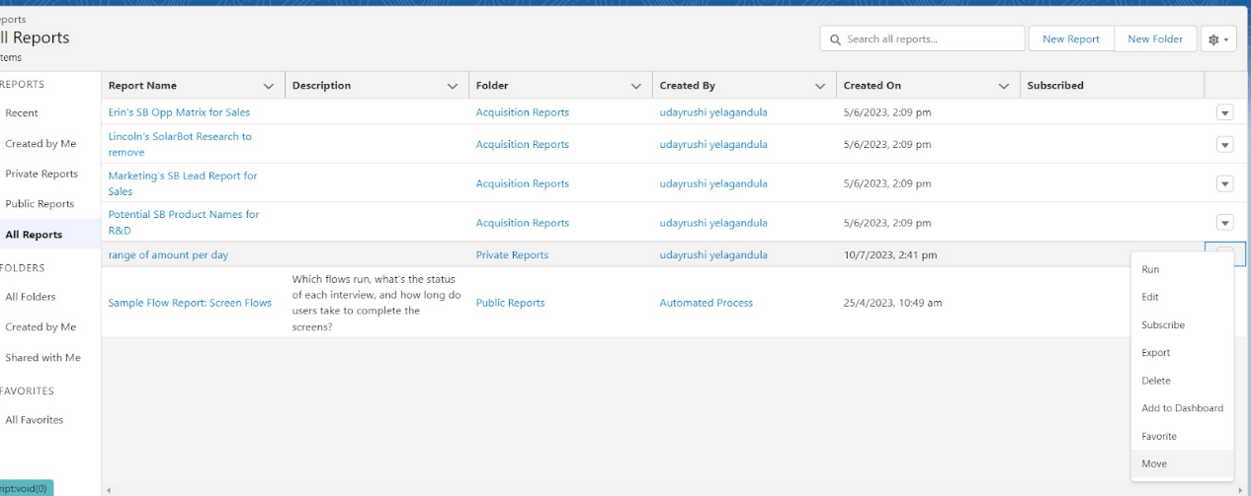
* 5. Select estimated rice per day folder and select folder.
* 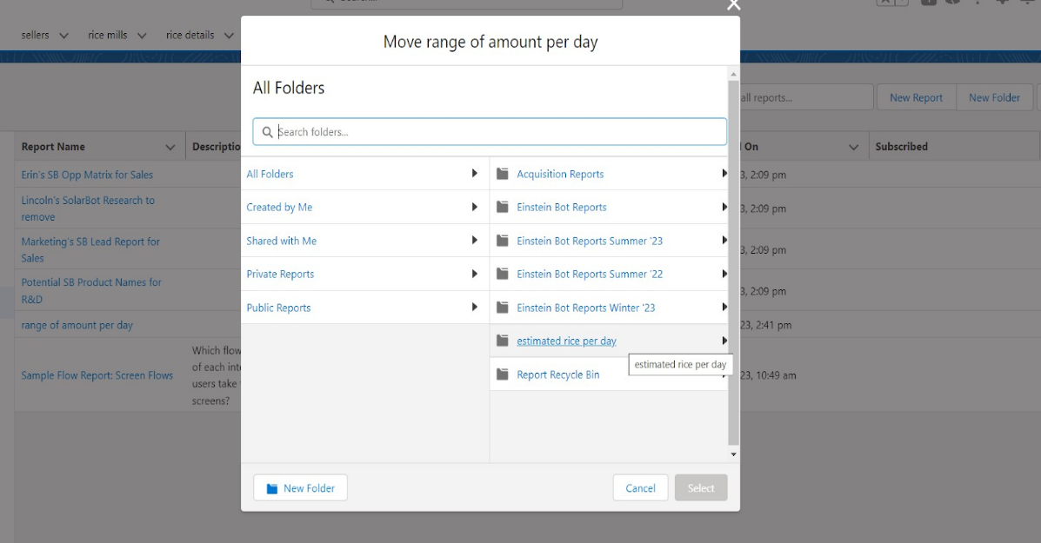

**TASK 12: Dashboards**

* **Create Dashboard Folder**
* Click on the app launcher and search for the dashboard.
* Click on the dashboard tab.
* Click the new folder, give the folder label as “ amount data dashboard”.
* Folder unique names will be auto populated.
* Click save.
* 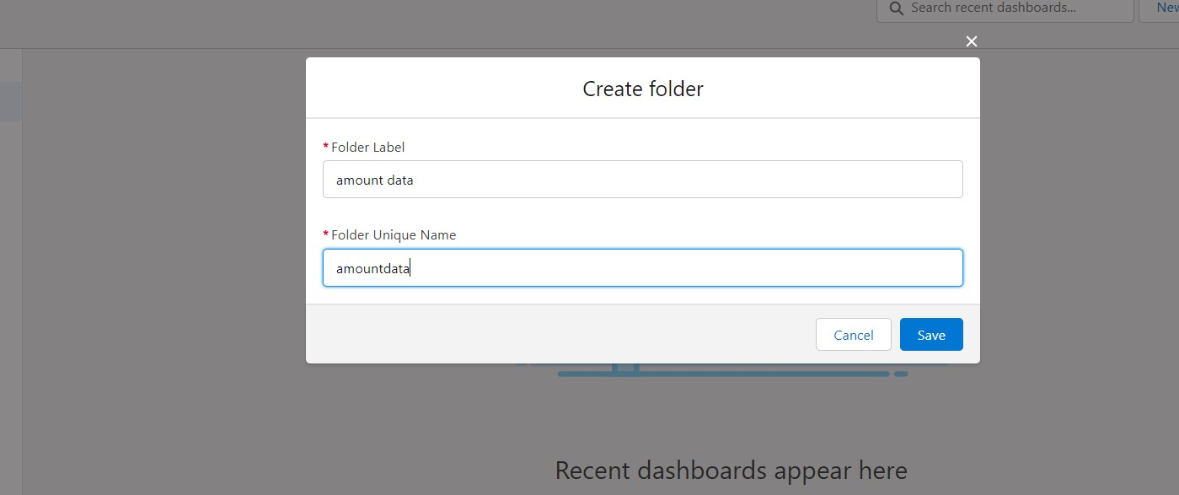
* **Create Dashboard**
* Go to the app >> click on the Dashboards tabs.
* 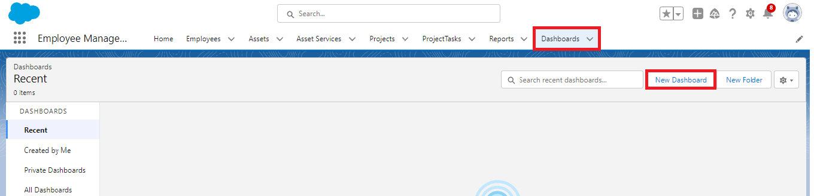
* Give a Name and select the folder that was created, and click on create.
* 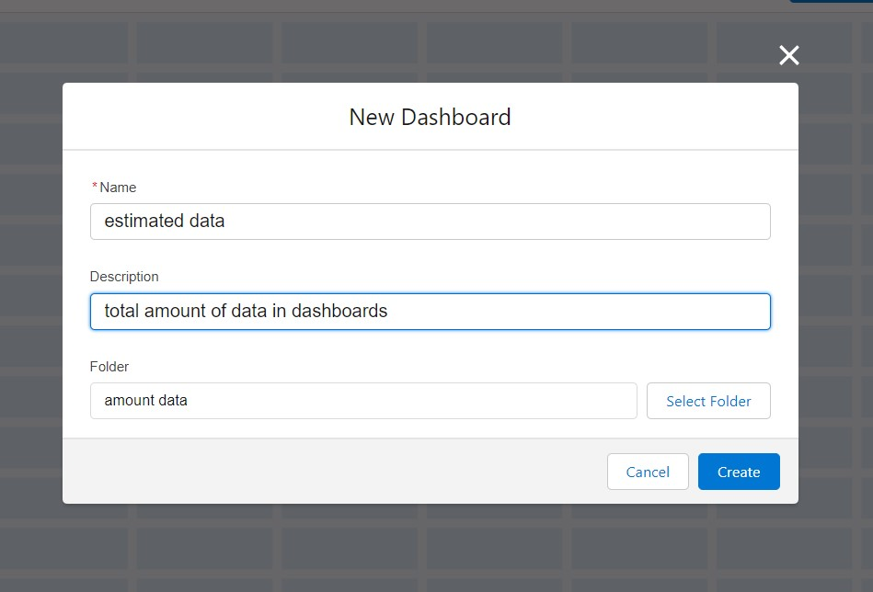
* Select add component.
* 
* Select a Report and click on select.
* 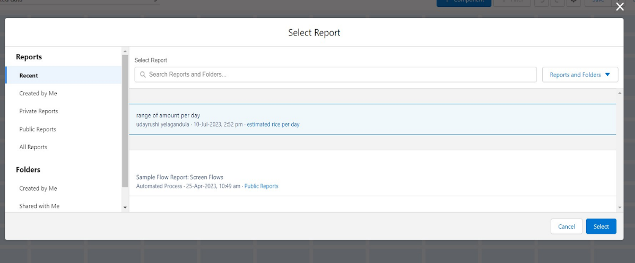
* Preview is shown below.
* 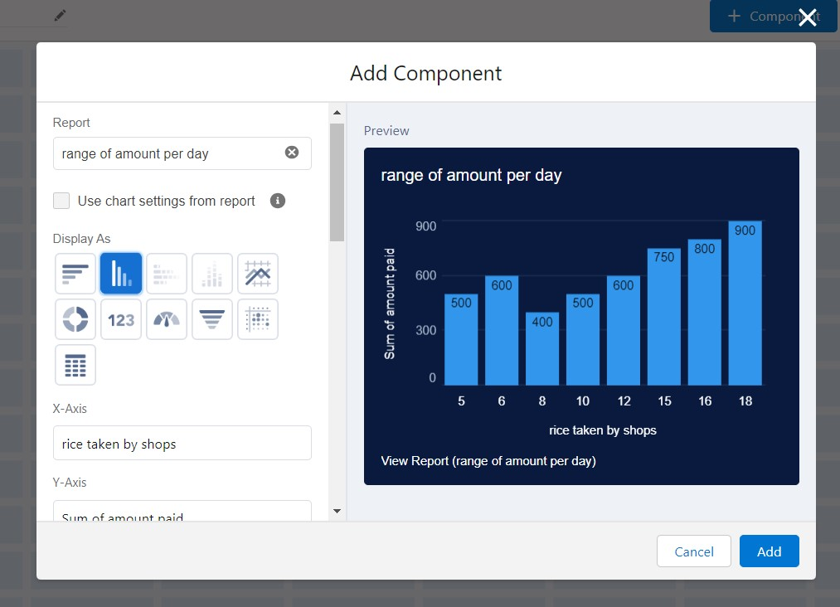
* Display as>> vertical bar chart
* X-axis >> rice taken by shops
* Y-axis >> sum of amount
* Y-axis range >> automatic
* Sort by >> rice taken by shops
* Component theme >> dark.
* Add the component
* Again select add component with above same steps
* 1.display as donut chart
* 2.sort by >> sum of amount
* 3.title>>range of amount per day
* 4.component theme dark
* 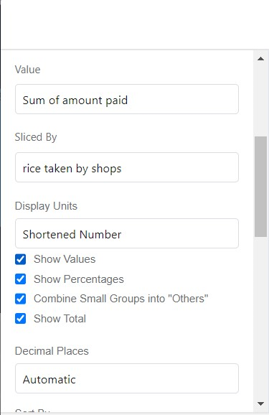
* Click add.
* Click save and done.
* 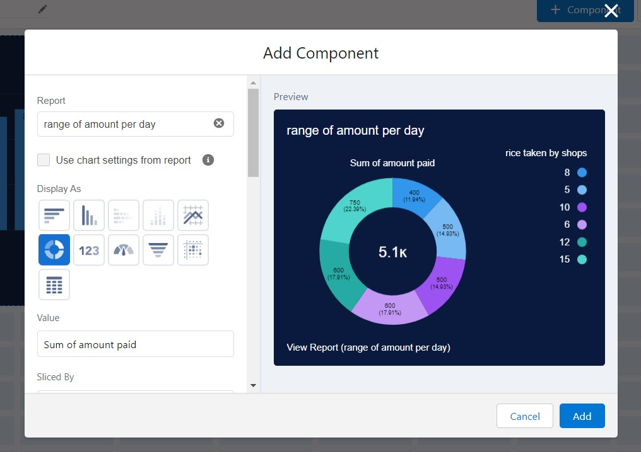

**TASK 13: Apex**

* **Creating An Apex Class (ConsumerRecord)**
* Login to the Salesforce account and navigate to the gear account in the top right corner.
* Then we can see the Developer console. Click on the developer console and you will navigate to a new console window.  
  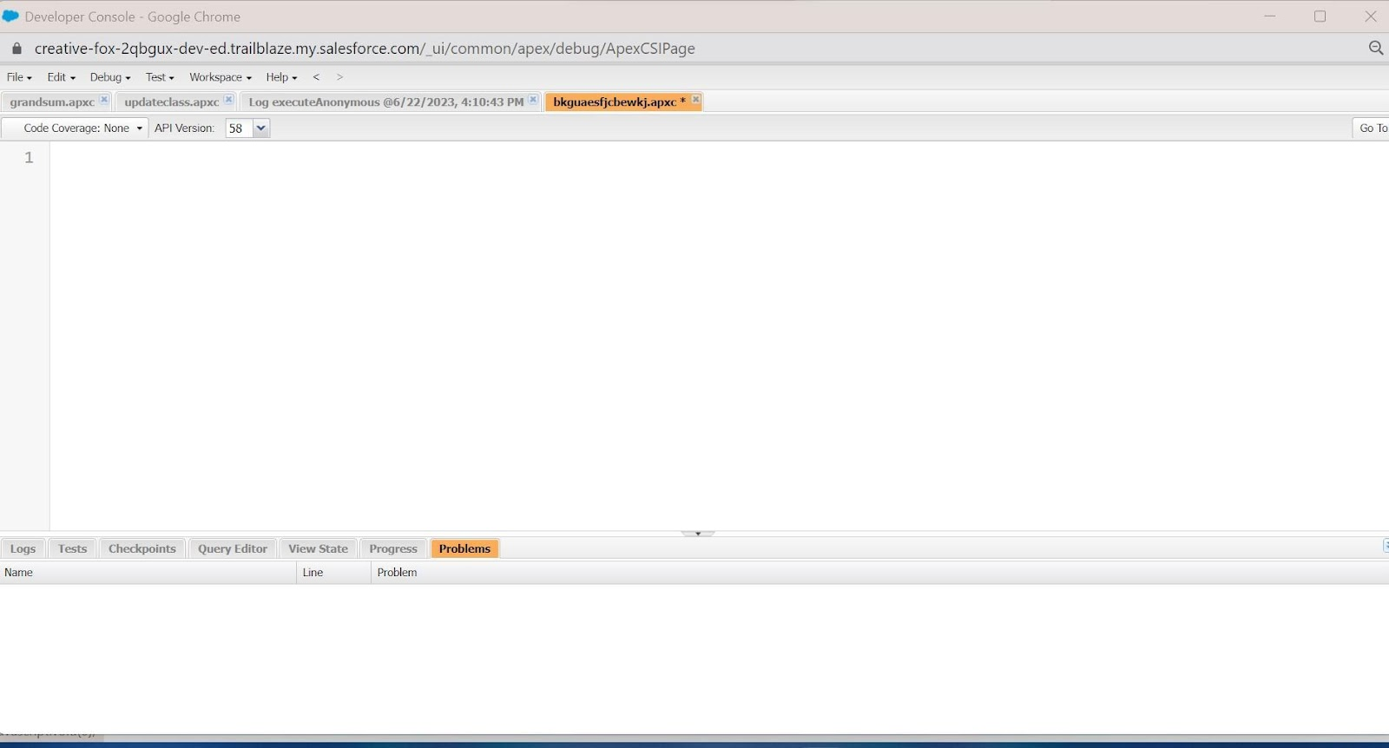
* Then you can see many tools in the Toolbar of the new console window. Click on File, New and Apex Class.
* Enter the name of the class(ConsumerRecord) to create a new class file.
* **Code Snippet :**
* class ConsumerRecord {
* public static void sendEmailNotification (List<consumer__c> con){
* for(consumer__c c:con)
* {
* Messaging.SingleEmailMessage email = new Messaging.SingleEmailMessage();
* email.setToAddresses( new List<String>{c.email__c});
* email.setSubject('Welcome to our company');
* email.setPlainTextBody('Dear ' + ' '+ ',\n\nWelcome to MY RICE!'+'You have been seen as a valuable customer to us. PLease continue your journey with us, while we try to provide you with good quality resources.'+'\n'+
* "We are proud to associate with valuable customers like you and we look forward to collaborating with you by providing more and more exciting discounts or even product offers too.' + '\n'
* +'So why taking a step back, take a leap of faith and shop with us more, while we provide with the valuable products and offers'+'\n'+'\n'+'\n'+
* 'Thankyou for buying '+ '' +'Here are some of the products that are brought by the customers who similarly bought products like this'+'\n\n');
* Messaging.sendEmail(new List<Messaging.SingleEmailMessage>{email});
* }
* }
* }
* 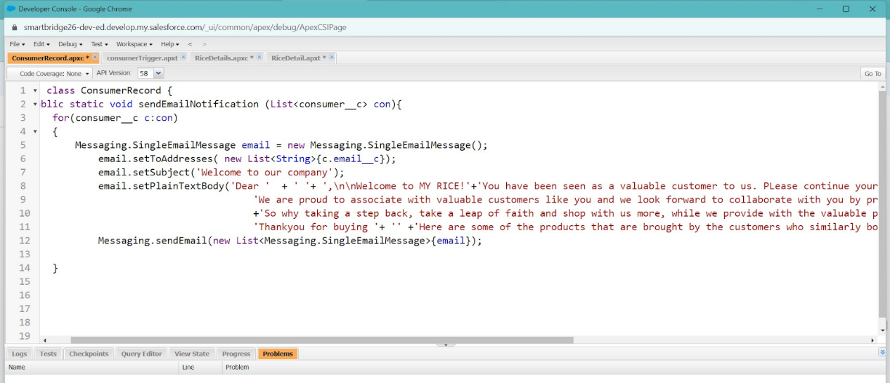
* **Creating An Apex Trigger** 
  + **How to create a new trigger :**
  + While still in the trailhead account, navigate to the gear icon in the top right corner.
  + Click on developer console and you will be navigated to a new console window.
  + Click on the File menu in the toolbar, and click on new? Trigger.
  + Enter the trigger name and the object to be triggered.
  + **Syntax For creating trigger :**
  + The syntax for creating trigger is :
  + Trigger [trigger name] on [object name]( Before/After event) {  
     //Trigger Logic
  + }
  + **Trigger code:**
  + trigger consumer Trigger on consumer (After insert) {
  + if(trigger.isAfter && trigger.isInsert) {
  + ConsumerRecord.sendEmailNotification(trigger.new);
  + }
  + }
  + 